INTRODUCTION TO CLOUD COMPUTING Lab
Task 02 (B) (Manage Governance via Azure Policy)

Name: Arshia M Ali
ID: 2280140
Section: BSSE 7-B

Task 1: Create and assign tags via the Azure portal.
- Create a Resource Group & Add a Tag:
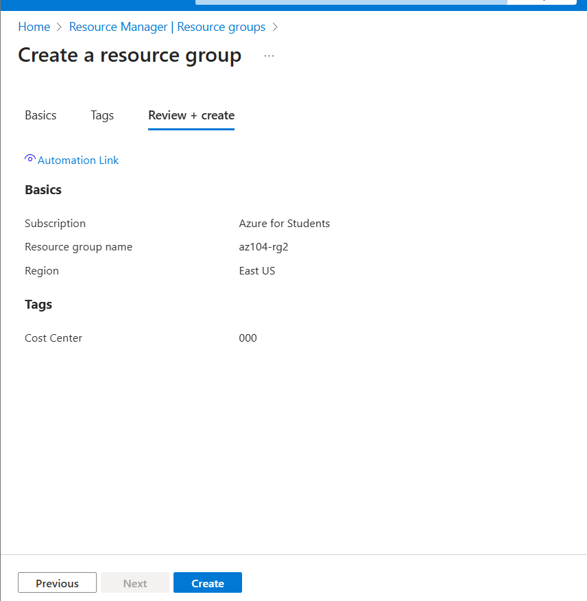

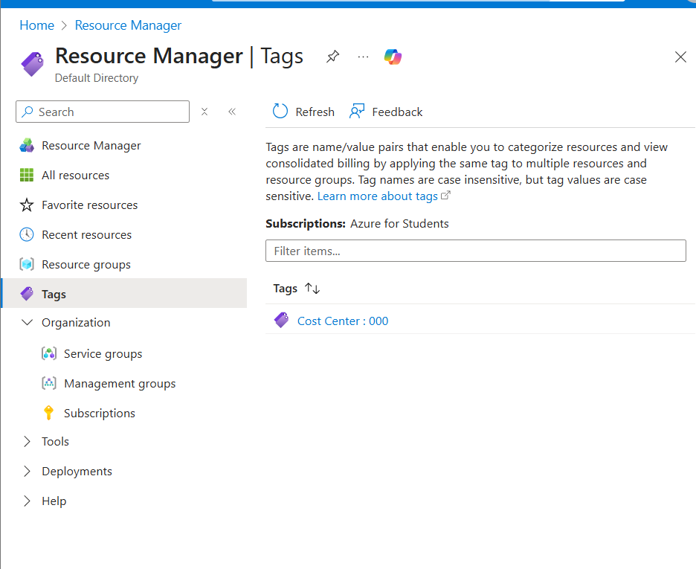

Task 2: Enforce tagging via an Azure Policy.
- Require a tag & its value on resources Policy:
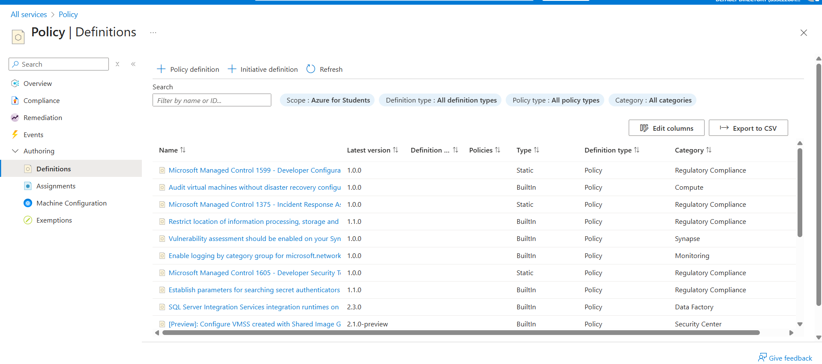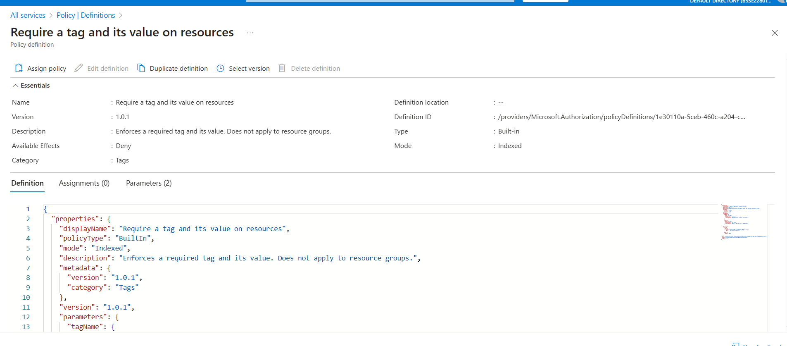

- Assign Policy & Implement tag in policy:
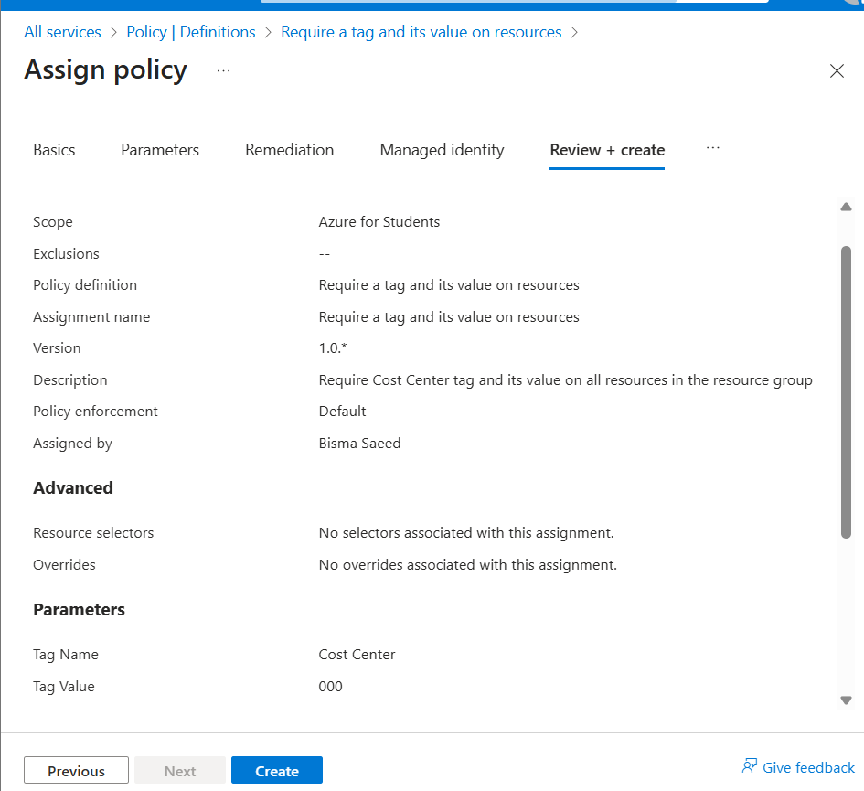
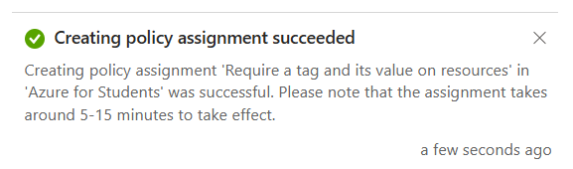

- Create a Storage Account:
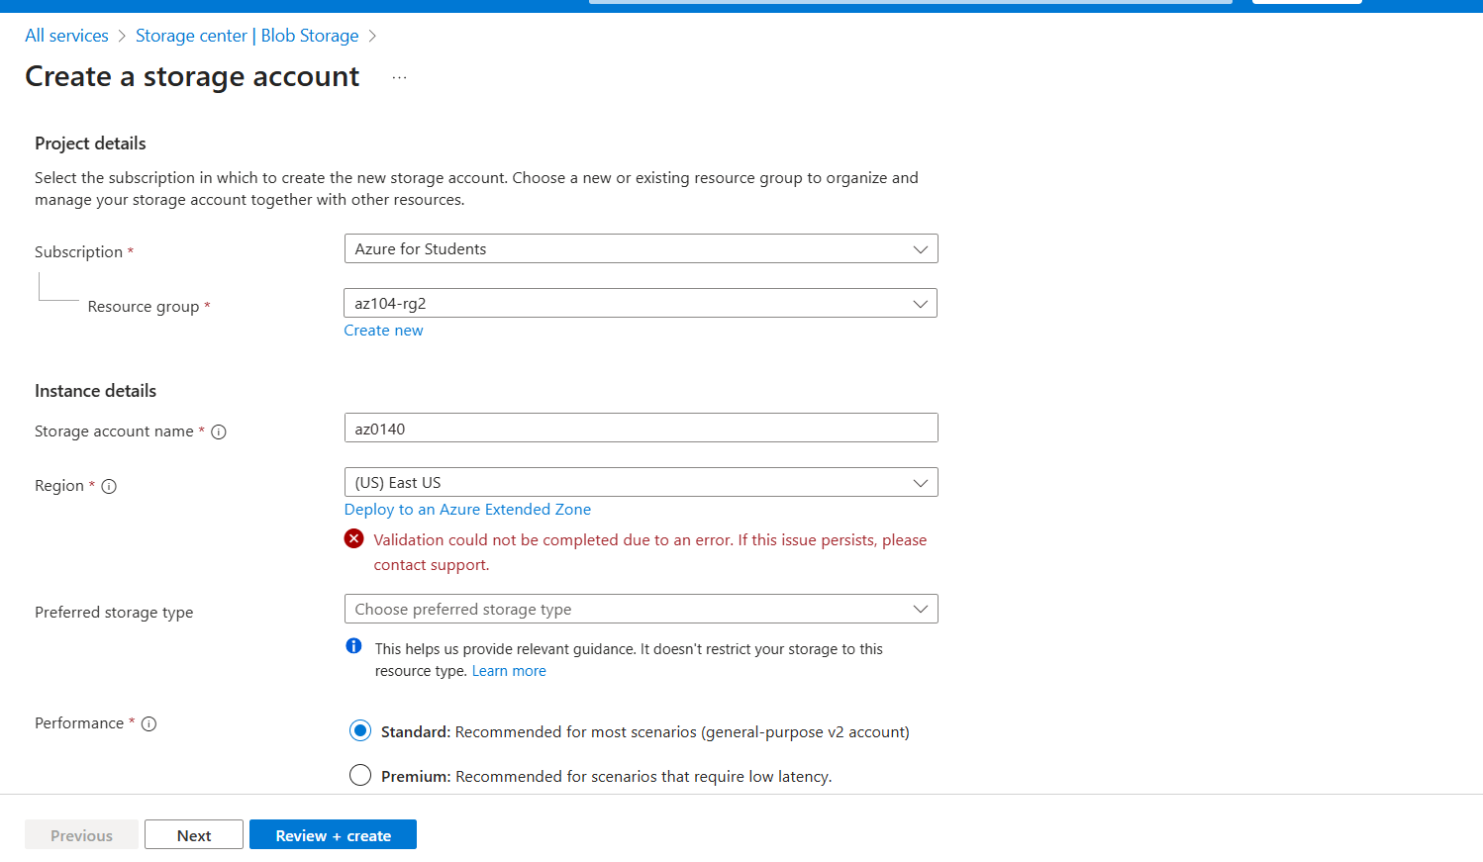

- Validation failed due to resource deployment was disallowed by the policy:
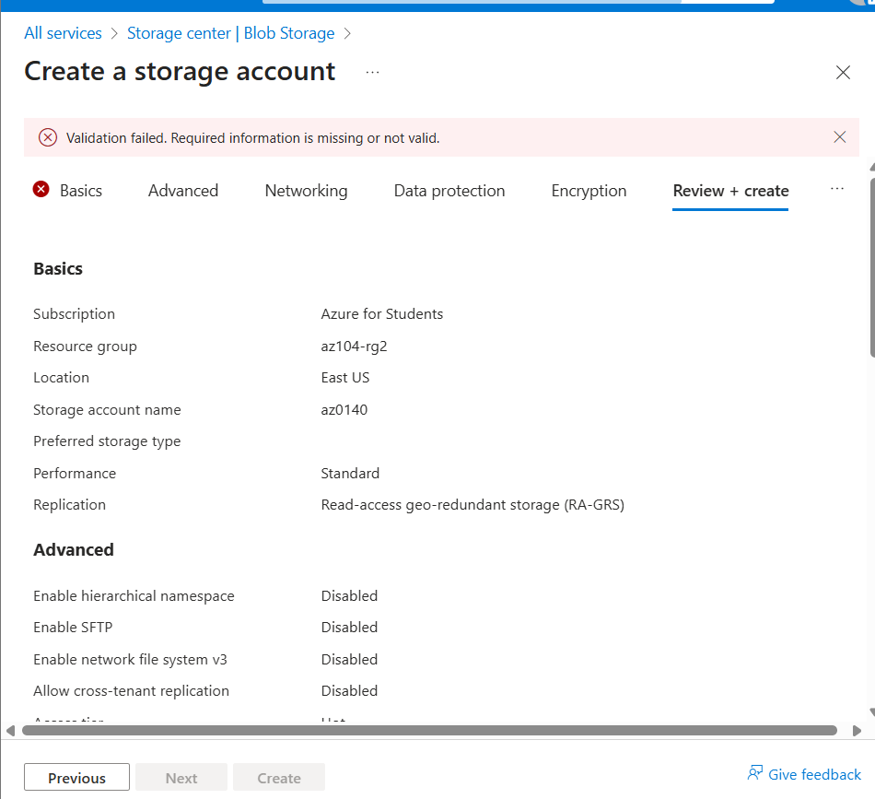

Task 3: Apply tagging via an Azure Policy.
- Remove Existing Tag Policy Assignment:
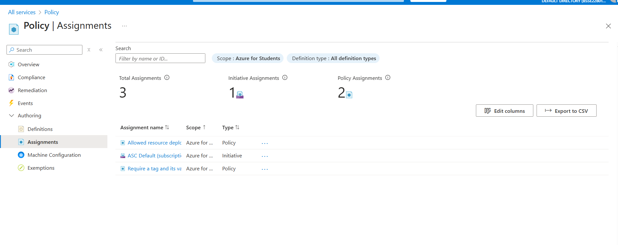
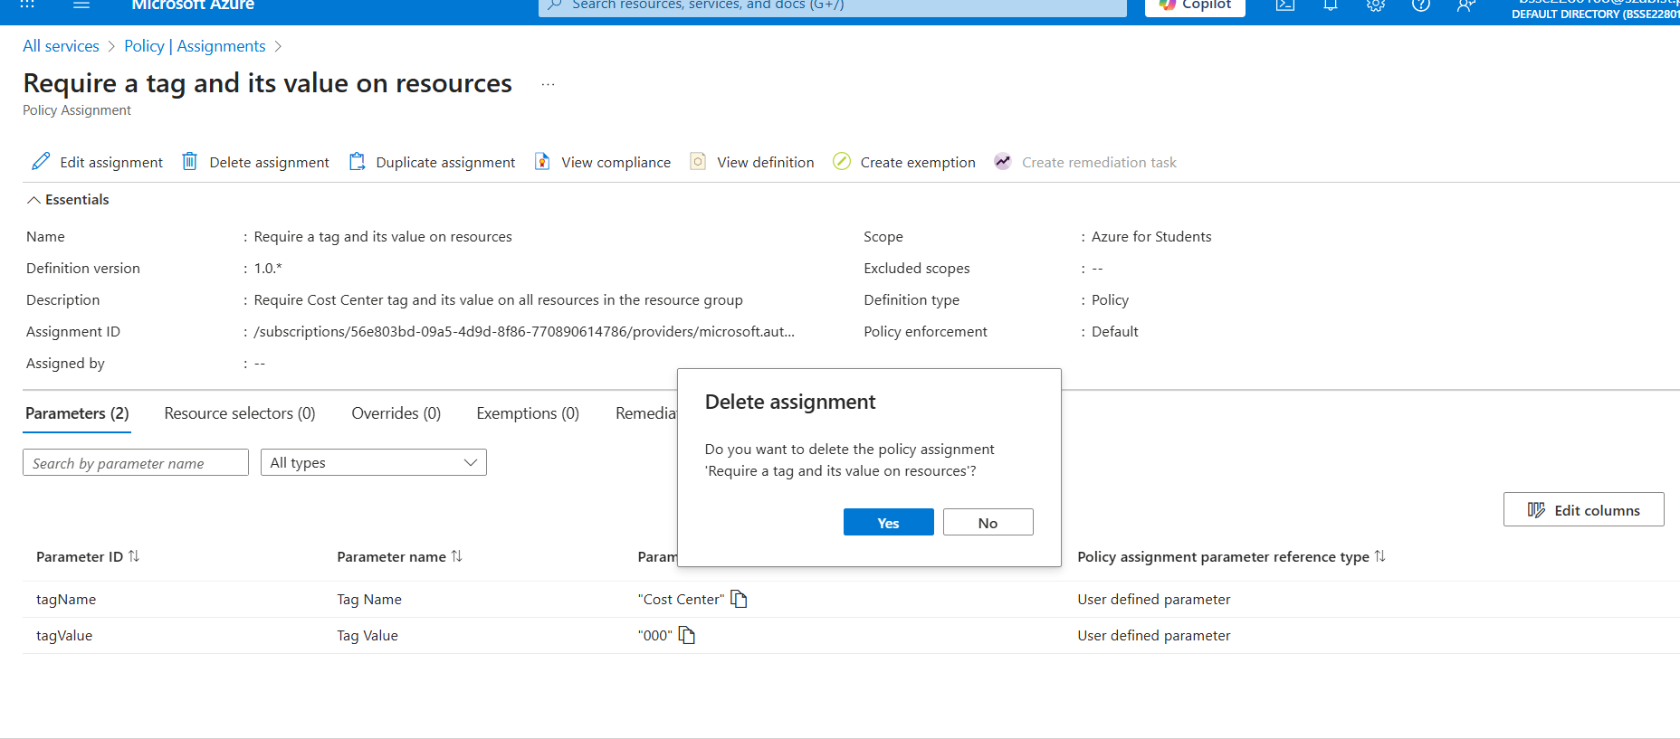
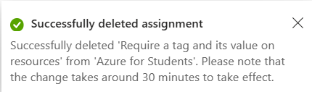

- Assign “Inherit a tag from the resource group if missing” Policy:
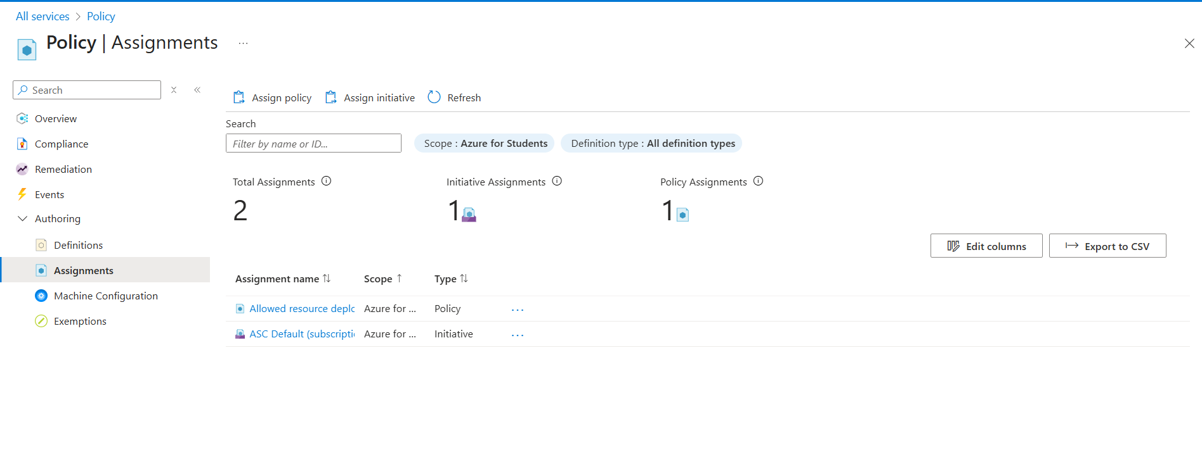
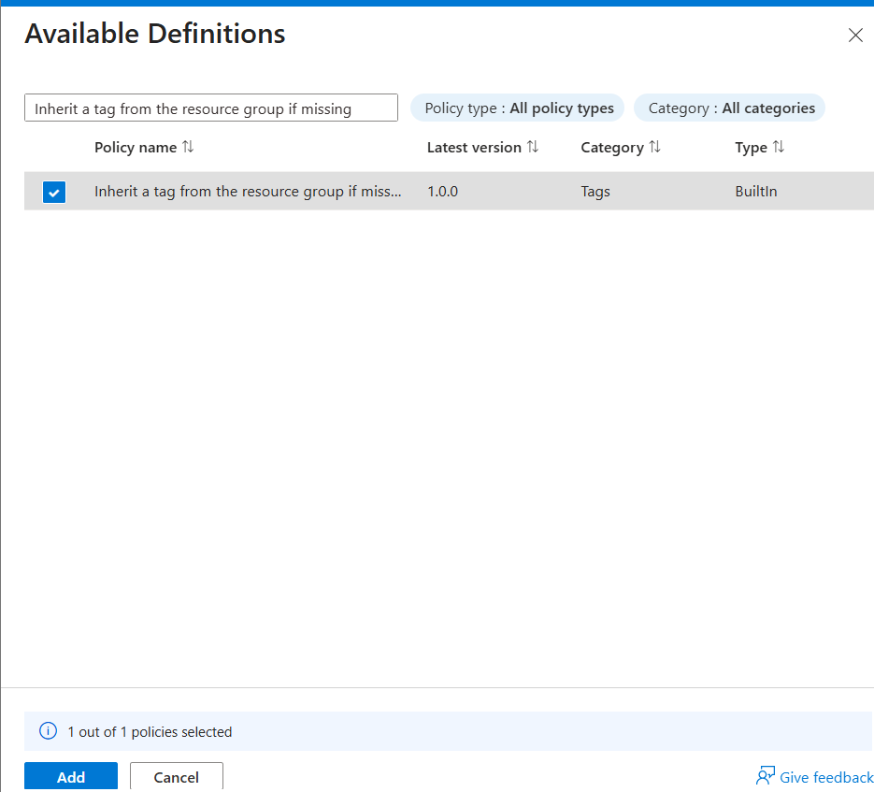
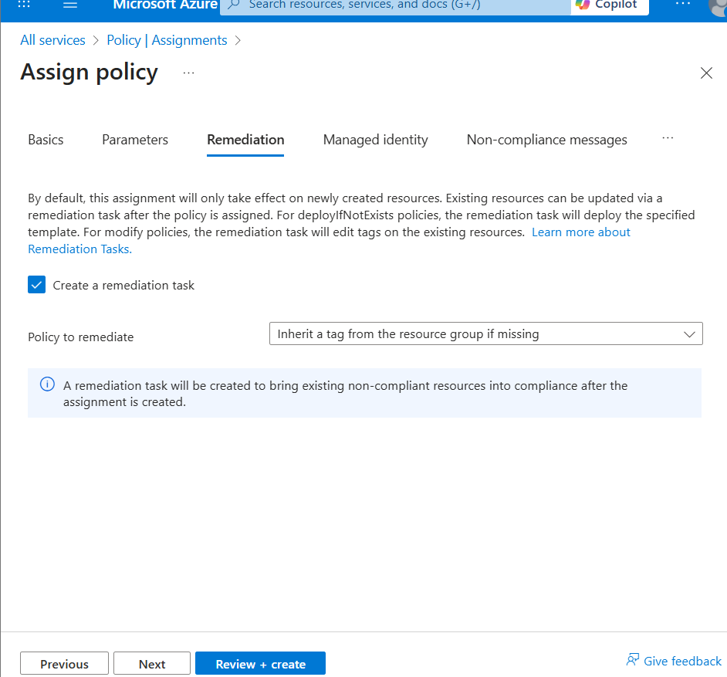
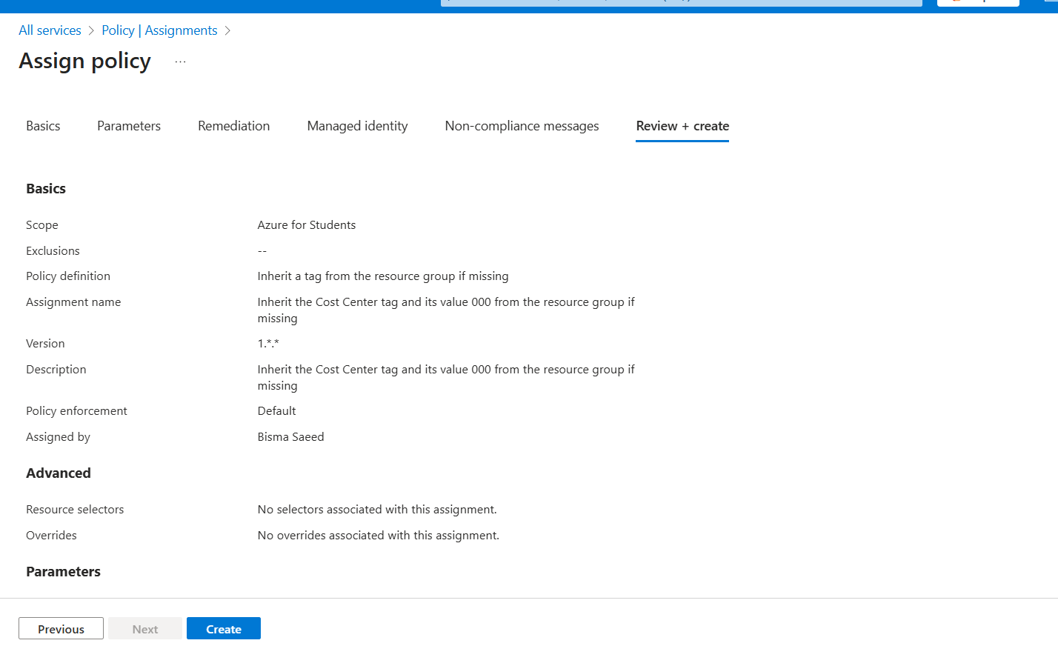
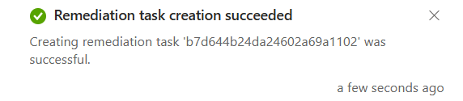

- Create Storage Account for Validation:
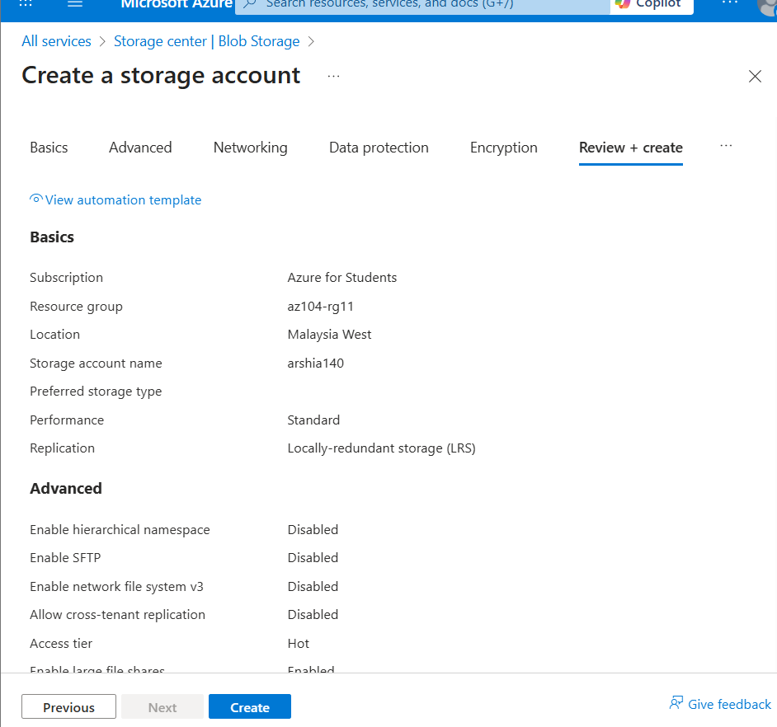
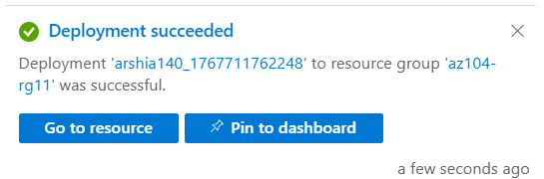

- Attempt to Delete Resource Group:
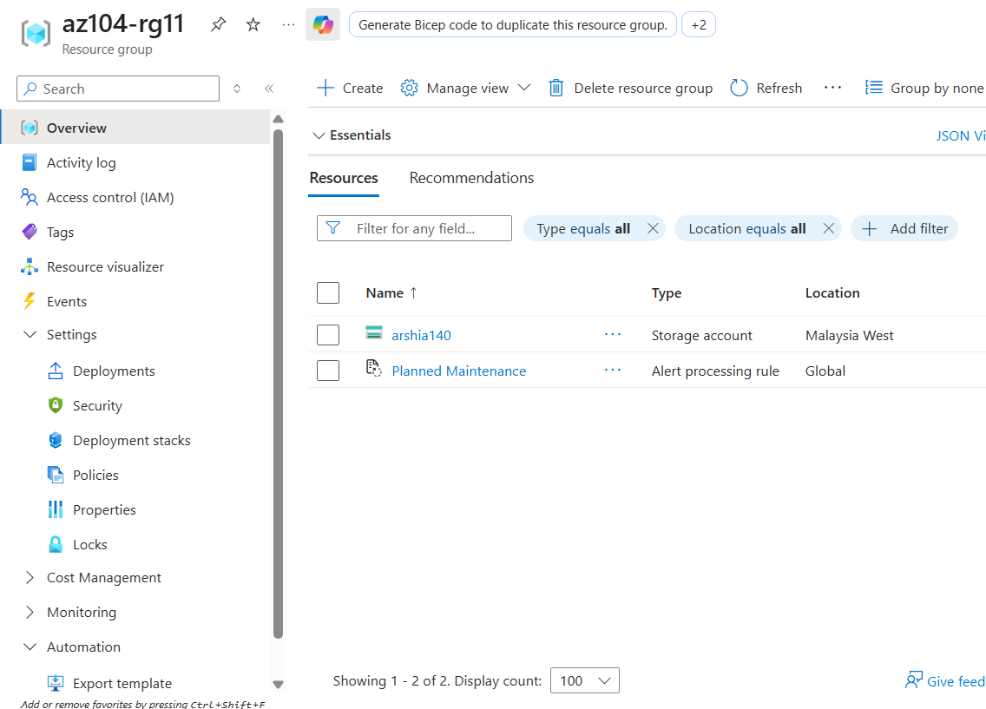

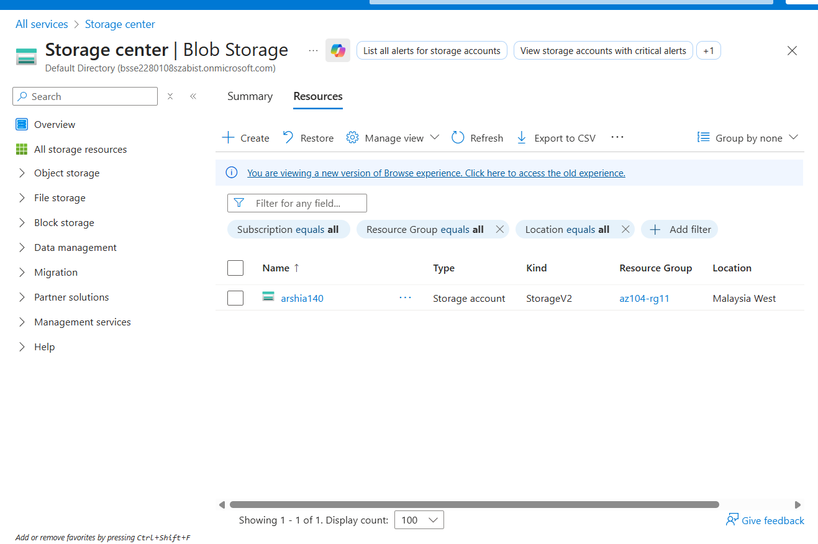

- Verify Tag Inheritance on Resource:
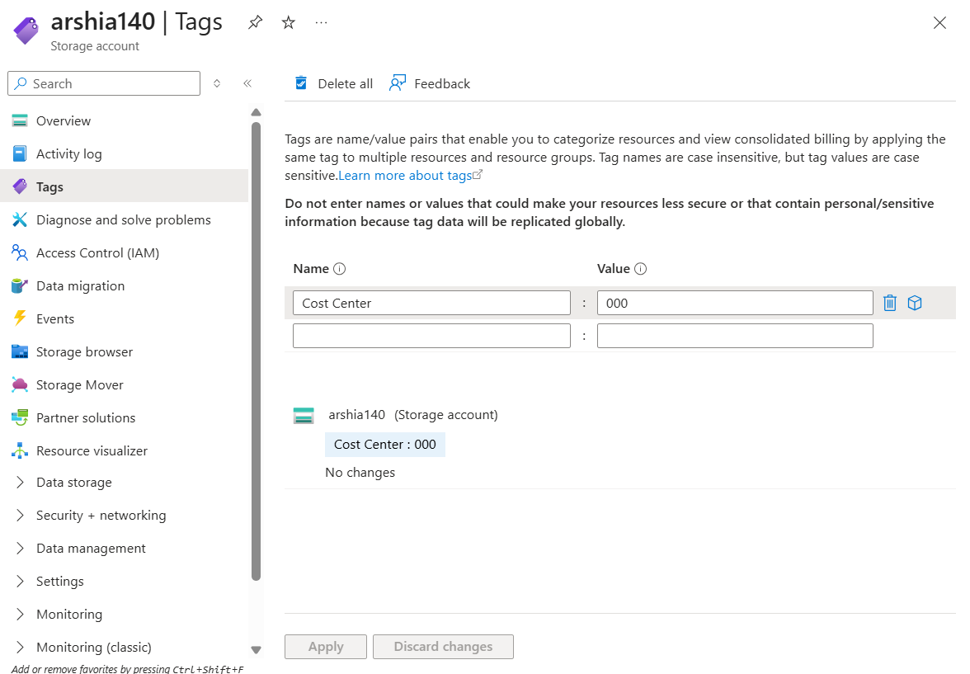

Task 4: Configure and test resource locks.
- Access Resource Group Locks & Add a Delete Lock:
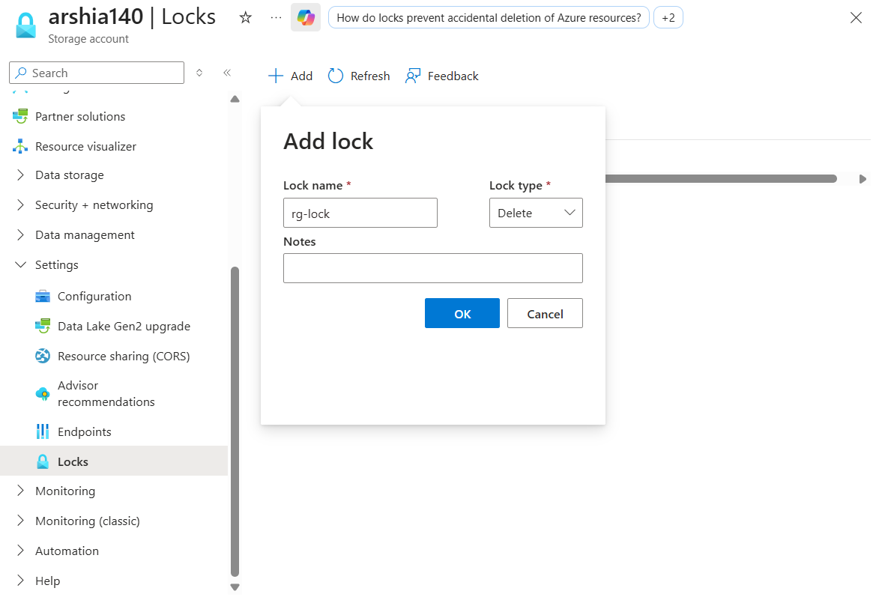

- Attempt to Delete Resource Group:
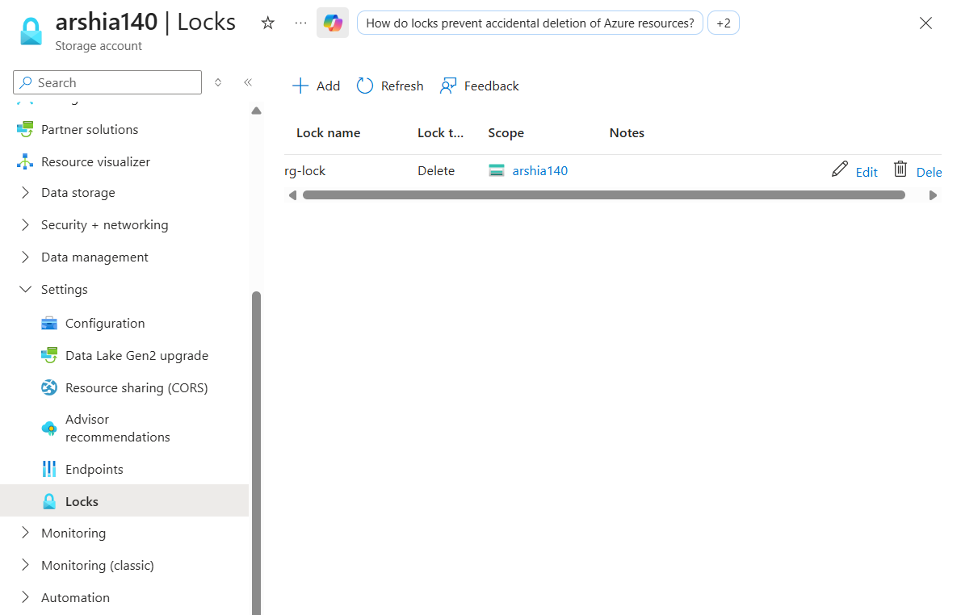

- Deletion Denied Notification:
